Waleed Mohamed Soliman
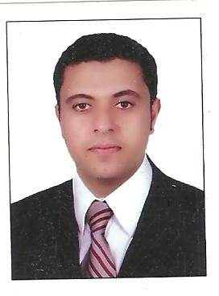

-Tanta, Gharbia, Egypt.
-Cellular: +966-0505143649
-E-mail: gasser_20082002@yahoo.com

PERSONAL INFORMATION

-Birth date: 03/05/1981
-Marital Status: Married
-Military Status: Exempted
-Nationality: Egyptian

CARRER OBJECTIVE

Seeking a challenging career opportunity that enhances my technical skills as well as my interpersonal skills. Being an independent person with a good experience in several fields which will help me to learn me in life.

EDUCTION

- Industry institute, Menofia University
- Department: production Technology, 2002

Computer skills

-Windows 7 & XP
-Microsoft Office XP
-Very good internet surfing skills
- Driving ID(SaudiaArabia)

Language skills

-Excellent command in Arabic Spoken, Read &Written
-Good command in English Spoken, Read &Written

PROFESSIONAL EXPERIENCE
1-RMK company for trading and contracting at KSA from01/01/2013till now as sales super visor

2-MEATEL WORLD COMPANY at SAUDIA ARABIA for iron decoration&stanles steel from 1/08/2009till 1/12/2012 as a SalesExecutive in( Riyadh&elqassem)

-Job Responsibility:

- Sale and market all type of company products
- Travel around the country to catch the target and get more customers and information.
- From other side trying to get available fast products for fast customers.

3-ERA Company for real estate from 01/02/2005 till 01/04/2009 as a Sales Executive.
-Job Responsibility:
- Sale and market all type of company products Flats, Lands, Villas, Stores and Complete prosperities
- Meet customers’ needs at different fields.

4Elsweedy Cables at 10th Ramdan City from 03/2003 till 10/2004 as quality controller.

PERONAL SKILLS

-Strong communication skills
-Ability to work under pressure
-Willing to re-locate

Thanks & Best Regards

